Post方式URL：<http://192.168.1.38:9090/api/MESAPI/Post>

Get方式URL：<http://192.168.1.38:9090/api/MESAPI/Get>

传入参数格式：

{

"API_KEY": "B9274B9CCA881E2EE0535AAAA8C0929620210118135023456",

"APP_NAME": "GET_PN_BY_SN",

"RETURN_TYPE":"JSON",

"IN_SN": "2J5220153981"

}

Return:

[

{

"APP_NAME": "GET_PN_BY_SN",

"RETURN_TYPE": "JSON",

"API_RESULT": "OK",

"RETURN_MSG": "MES_OK",

"SN_STATUS": "Y",

"WORK_ORDER": "13107609",

"PART_NO": "14800150",

"THREE_PN": "34450162",

"FLASHIC_PN": "60077049",

"CONTROLLER_PN": "61001730"

}

]

Postman测试画面—量产工单

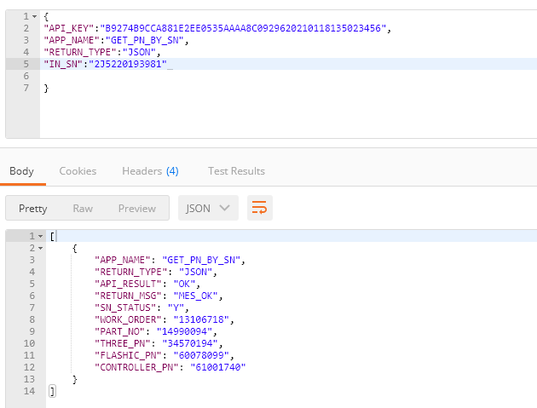

Postman测试画面—重工工单

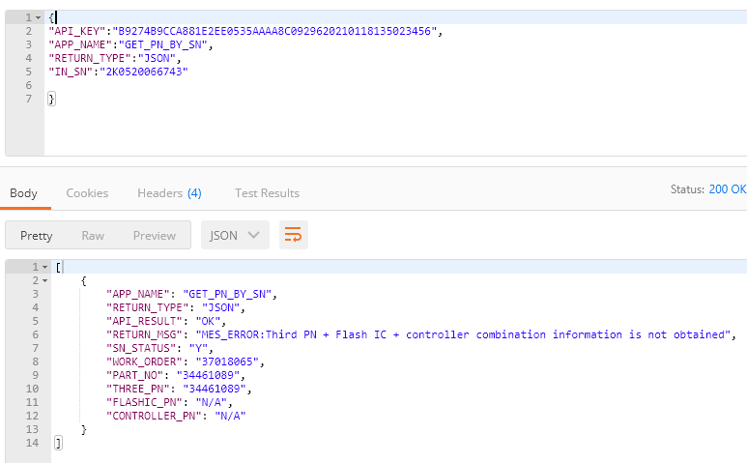

Postman测试画面—数据库中不存在的SN

